

Registration is now open for Penn State's College of Communications 2013 summer camps in Multimedia Journalism and Film-Video.

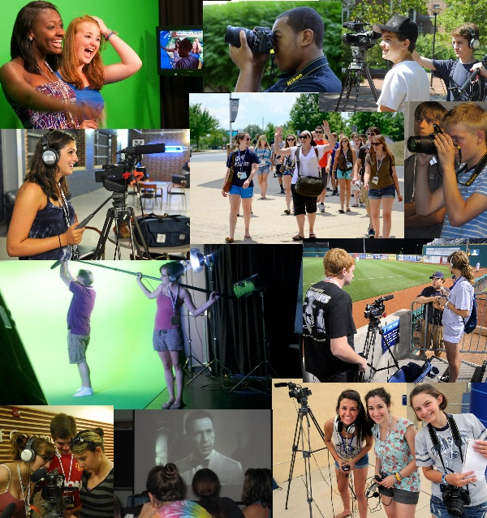

Join us for five days of FUN and career exploration.
Penn State is looking for talented high school students to join us for our 2013 summer camps in Multimedia Journalism and Film-Video.
We would love to connect with you. Please let us know if you have any questions or would like more information.


All high school students who will be enrolled in the fall of 2013 are eligible.

For complete information about the camps:
http://www.outreach.psu.edu/communications-camps/

Dates: July 7 - 11, 2013

The camps will be held at the University Park campus in State College, PA.

PSUCommCamps
 | We've got it all  Broadcast  Photojournalism  Sports  Social Media  Arts & Culture  Weather
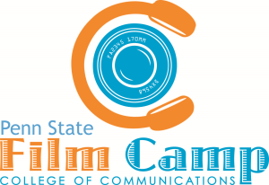 | 3 films in 4 days  Storyboarding  Filming  Acting  Directing  Editing  Producing
Watch films by summer 2012 campers and current film students:http://vimeo.com/pennstatefilm
Check out the kinds of multimedia journalism projects being done at Penn State: http://commedia.psu.edu/

2012/2013 College of Communications Awards & Recognitions

Journalism
Back-to-back national champions in the intercollegiate writing competition of the William Randolph Hearst Foundation's Journalism Awards Program.
Penn State had 13 first-place winners, 12 second-place winners and six third-place winners at the 2012 Society of ProfessionalJournalists Region 1 Mark of Excellence Awards.
Journalism alum, Sara Ganim '08, won the Pulitzer Prize in 2012 and was hired by CNN in 2013.
Student Newscast - Best of Festival to Penn State broadcast majors for the Centre County Report in the 2013 Broadcast Education Association Festival of Media Arts.

Film
Tyler Walk ('04 Film) - co-writer and co-editor for "How to Survive a Plague," earned an Academy Award nomination for Best Documentary Feature.
Brandon Hess (Film '10) won best short film from the AFI Conservatory.
Brad Robinson ('00 Film) - "Political Animals," Director's Guild nomination for Outstanding Directorial Achievement in Movies for Television and Mini-Series.
Brandon Kelley ('11 Film) was the winner of the Silver Award (Student Category) in the 2012 California Film Awards.

